|  |  |
| --- | --- |
| **Ex. No. 6** | **Implement Signature Scheme – Digital Signature Standard** |
| **Date of Exercise** | 05.10.2023 |

**Aim**

To implement digital signature standards and to prove its cryptography.

**Description:**

DSS is a set of rules and guidelines that specify how digital signatures should be generated and verified for the purpose of ensuring data integrity and authentication in electronic communications. Digital signatures are cryptographic techniques used to verify the authenticity and integrity of digital documents or messages.

DSA (Digital Signature Algorithm): The DSA is the core algorithm specified in DSS for generating and verifying digital signatures. DSA is based on the mathematical properties of modular exponentiation and the discrete logarithm problem. It is designed to provide data integrity and authentication.

**Program:**

import random

p = int(input("P: "))

q = int(input("Q: "))

x = int(input("Private_Key: "))

M = int(input("Hashed message: "))

h = random.randint(2, p-2)

g = int(h ** ((p-1)/q))

print(h, g)

y = (g ** x) % p

k = random.randint(1, q-1)

print("Public_Key: ", y)

print("Random Integer: ", k)

r = ((g**k) % p) % q

for i in range(1, q):

if k*i % q == 1:

s = (i*(M + x*r)) % q

break

dig_sign = [r, s]

print("Digital Signature: ", dig_sign)

w = 0

r, s = dig_sign[0], dig_sign[1]

for i in range(2, 20):

if (i*s) % q == 1:

w = i

break

u1 = (M * w) % q

u2 = (r * w) % q

v = (((g ** u1) * (y ** u2)) % p) % q

print("W: ", w)

print("u1: ", u1)

print("u2: ", u2)

print("V: ", v)

if v == r:

print("Signature is Verified")

else:

print("Signature is not Verified")

**Output Screenshot:**

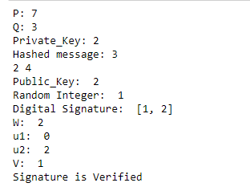

**Result**

Thus, implementation of Digital Signature Standards using Cryptography has been executed successfully.